Use of Force
Q3 2020/21 – October to December

Data limitations to note: This summary provides an insight into the number and content of the submitted use of force forms. It should be noted that this does not provide an overview of the incidents themselves. More than one form can be submitted against an individual incident if multiple officers are involved. It should also be noted that each form submitted can include multiple reasons for the use force and various tactics may have been used. Details of the subject on the forms submitted will be duplicated. Therefore figures provided are purely an indication of the forms themselves.

1,488
Use of Force submissions in Q3 2020/21
Impacting factor
Use of Force is used in a very small portion of incidents attended

Alcohol as an impacting factor made up 23.4% of all factors given

Locations

Reasons for use of force

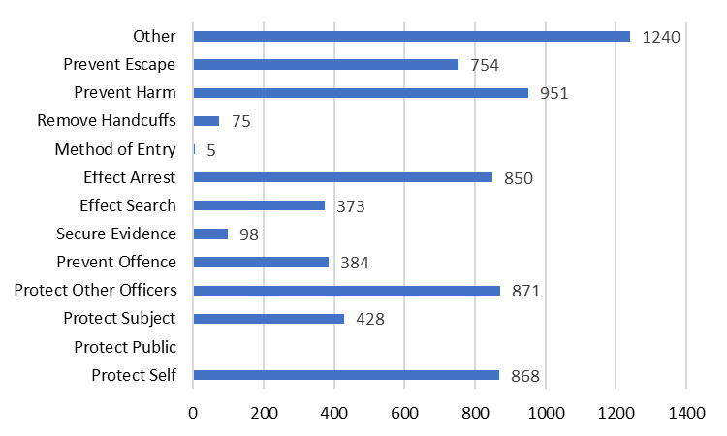

29.1% of forms submitted related to a street / highway
16.9% were in custody

Use of force is predominantly used to protect self. Police Officers have a positive duty to act and therefore will often place themselves between the threat and the public to protect others.

Tactics used

Physical restraint is the most used tactic.

Subjects of forms submitted


8 out of 10 subjects were Male



In 46.8% (697) of the forms submitted the subject was aged between 18-34 years old
80.4% (1,197) male and 19.6% (291) female

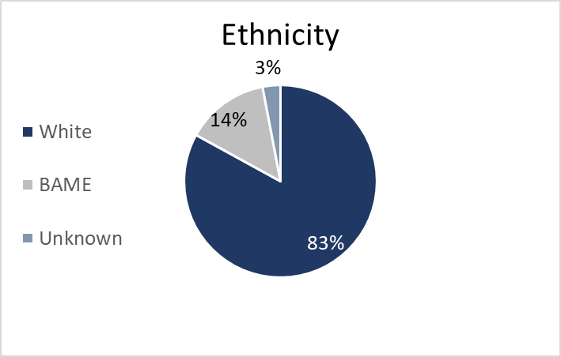

If the same tactic is used more than once by an officer at an incident it is only counted once. However as more than one tactic can be used in a single incident then the overall totals for tactics used will be higher than the number of incidents recorded.

